VERY EASY: Make a directory on your desktop and name it “Basics”.

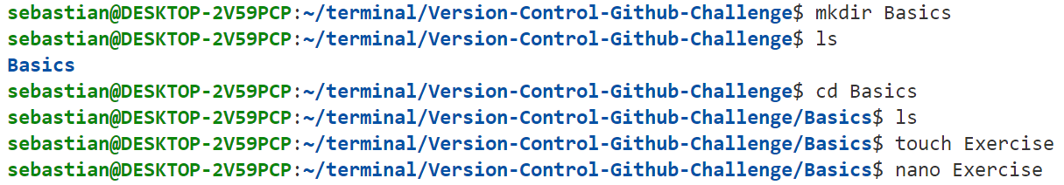

EASY: In your “Basics” directory, create a text file called “Exercise”.



MEDIUM: In the new text file you created, answer the following questions:



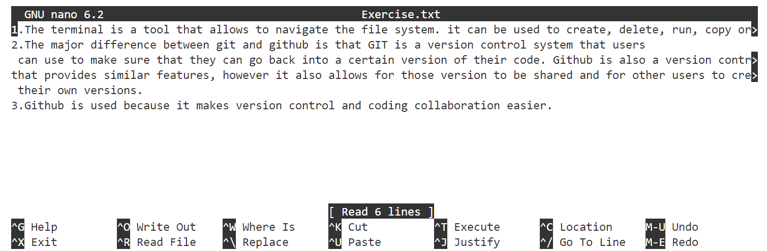

HARD:

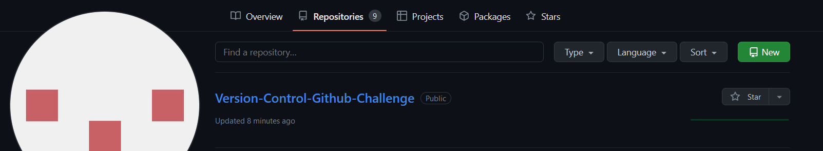

VERY HARD: Push the “Basics” directory up to the new repo you created.

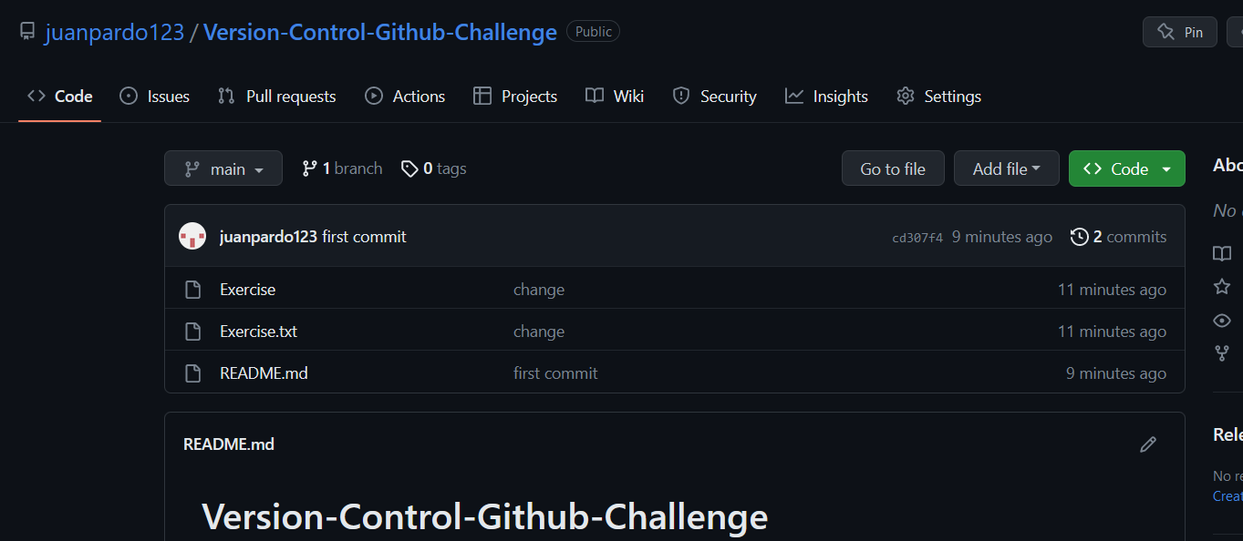

https://github.com/juanpardo123/Version-Control-Github-Challenge.git